Austin Smothers

CISP 310

Assignment 5
; PosNegZero.asm, a program which finds if
; a number is positive or negative
; and repeats until the user enters 0
; Austin Smothers
; CISP 310
; October 31, 2017

.586
.MODEL FLAT

INCLUDE io.h

.STACK 4096

.DATA
promptNum BYTE "Enter a Number", 0
string DWORD 40 DUP (?)
resultLbl BYTE "The Number is", 0
resultPos BYTE "Positive", 0
resultNeg BYTE "Negative", 0

.CODE
_MainProc PROC
while1:
body:
input promptNum, string, 40 ; read ASCII characters
atod string ; converts string to a decimal

cmp eax, 0 ; compare input in eax to 0
jz exit ; terminate program if input is 0
js negNumber ; jump if the number is negative

output resultLbl, resultPos ; didn't jump, result is odd, output
jmp while1 ; jump past the even number output
endwhile1: jmp exit ; jump to exit at end of while1

negNumber: output resultLbl, resultNeg ; jumped, result is even, output

jmp while1 ; jump back into while loop

exit:

mov eax, 0 ; reset eax

ret
_MainProc ENDP
END ; end of source code

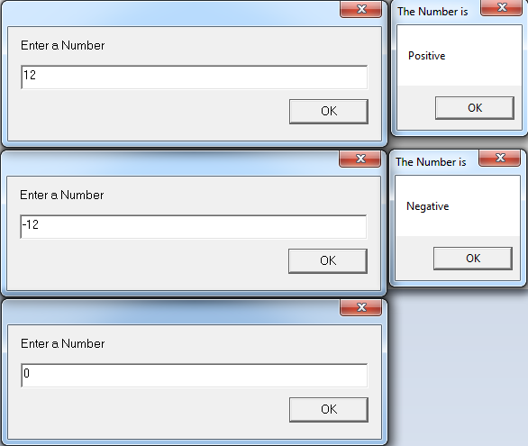
; Sum20.asm, a program which finds the
; sum of even numbers from 20 to 0
; Austin Smothers
; CISP 310
; October 31, 2017

.586
.MODEL FLAT

INCLUDE io.h

.STACK 4096

.DATA
resultLbl BYTE "Sum of even nums from 20 to 0", 0
sumNum DWORD 40 DUP (?), 0

.CODE
_MainProc PROC

mov eax, 20 ; set eax to 20

while1: cmp eax, 0 ; set flags, stop looping when eax is 0
body:
add sumNum, eax ; add the value in eax to sumNum
dec eax ; decrement eax
dec eax ; do it twice so we only do even nums

jz exit ; jump to exit if eax is 0

jmp while1 ; repeat the loop
endwhile1: jmp exit ; jump to exit at end of while1

exit:

dtoa sumNum, sumNum ; convert sumNum from decimal to string
; for output

output resultLbl, sumNum ; output the result

mov eax, 0 ; reset eax

ret
_MainProc ENDP
END ; end of source code
